Chicago Greens
http://www.illinoisgreens.org/

For Information: Charles Paidock (312) 842-5036 cpaidock@hotmail.com
Robert Rudner (312) 719-5719 robertrudner@gmail.com
Wes Green (773) 306-5402 wesgreen@ripco.com

Date: February 5, 2015

To: US Congress: Transportation, Energy

From: Charles Paidock, Secretary cpaidock@hotmail.com
3211 S. Union Ave (312) 842-5036
Chicago, IL 60616 (312) 714-7790 cell

Re: Crude Oil Rail Tank Cars

# of Pages: One (1) including cover

Please see website for articles regarding safety concerns of residents of Illinois:
www.illinoisgreens.org
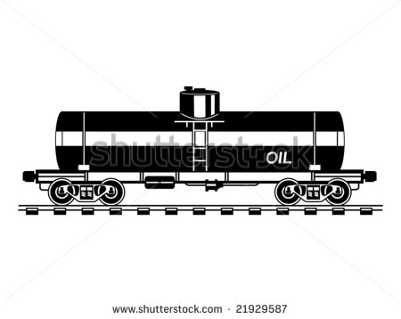
Thank you for your assistance in this regard concerning an important ecological issue.

Fiery derailment near Dubuque involved outdated tank cars
DOT-111s prone to puncture, but still heavily used
By Erin Jordan, The Gazette February 4, 2015 7:27 PM

Dubuque County — A train derailment Wednesday near Dubuque that caused three tank cars to erupt in flames and three others to plunge into the icy Mississippi River involved outdated cars prone to punctures and spills.

Eleven cars left the track, with 10 of those carrying ethanol, officials reported. Three of those cars caught fire and three slipped into the river.

DOT-111s, black, tubed-shaped tank cars, make up about 70 percent of the U.S. tank car fleet. The outdated cars have been blamed for explosions and spills during derailments across North America.

Tens of thousands of the cars are still in use because of the high volume of crude oil being shipped from the Bakken region or North Dakota, Montana and Canada.

“You have these older cars that don’t meet the specs carrying these flammable liquids, this is what you’re going to get,” Albert Ratner, a University of Iowa associate professor of mechanical engineering who studies fires during train derailments, said about Wednesday’s crash.

“You could have problems with it going downstream and spreading out the environmental effect,” he said.

