40+ Crude Oil Tanks Car Trains Pass Somewhere Through Chicago Every Week
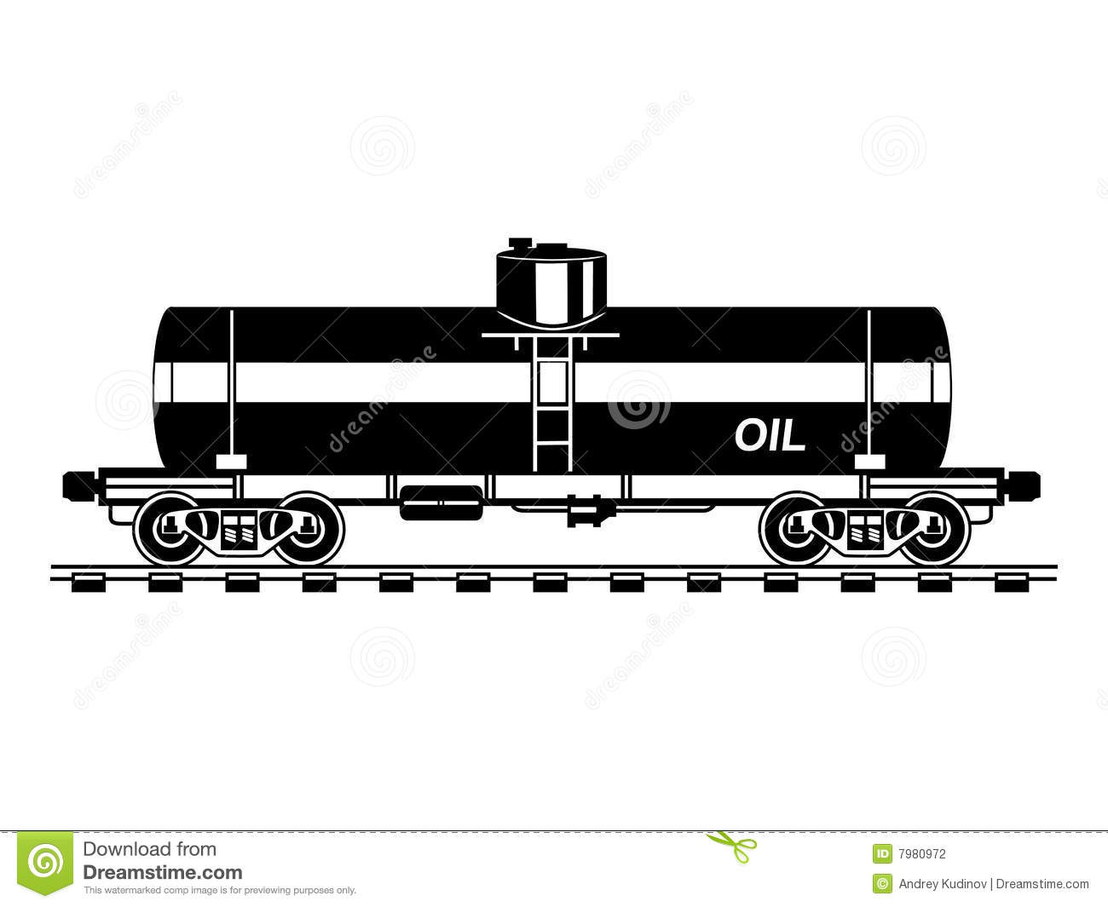
Take a Field Trip to See

Oil Trains: The Routes, the Rail Yards
Saturday, July 9th, from10:00 AM to 2:00 PM
Get ready to be up close & personal with the oil trains (BOMB TRAINS) rumbling through our city on rail lines never designed for this type of traffic.
We'll visit the yards that the trains pull through, and we'll learn to identify and report which tank cars are hauling the dangerous cargo, and where they travel through Chicago.
Meet school bus - bring your lunch – cost is $10 at 845 W. Cermak Rd (22nd Street), just west of Halsted
Please arrive by 9:45 AM- Look for yellow school bus at Cermak & Peoria. Ample street parking. Near bus stops and Orange Line Halsted stop. Pack a lunch
Register at:
https://actionnetwork.org/events/oil-trains-the-routes-the-rail-yards-a-field-trip
or on Facebook: https://www.facebook.com/events/1085337581513163/?active_tab=highlights
Host Contact Info: 773-370-3305 or tomshepherd2001@yahoo.com
WITH PARTICIPATION OF: ChiOilByRail, Railroad Workers United, Frack-Free Illinois, Southeast Environmental Task Force, Chicago Greens, STAND, and others

